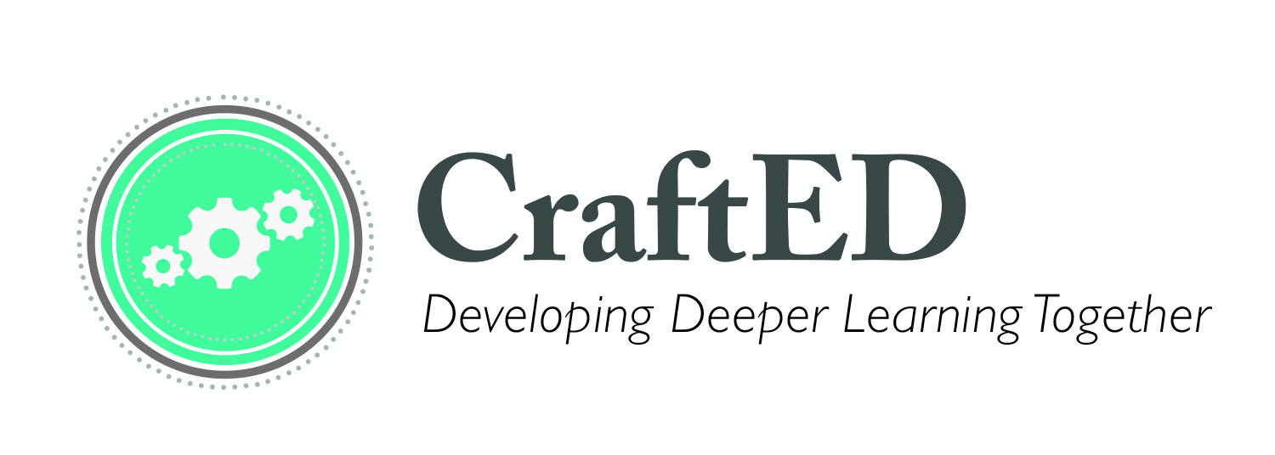
Project Planner Part I
Enduring Understanding (grounded in your discipline): _________________________________________________________________________________________________________

Standards, Skills:
_________________________________________________________________________________________________________

Driving Question:
_________________________________________________________________________________________________________

Final Product(s):
__________________________________________________________________________________________________________

Culminating Experience: __________________________________________________________________________________________________________

Benchmark Phases: ---> Possible Assessments:

1. 1.

2. 2.

3. 3.

Tips for your Craft

Enduring Understanding: This is what you would like your students to remember 10 years from now. The EU transcends time and context. A solid EU resides at the heart of your content area (meaning it is grounded in standards) AND also seeks to provide real-world context and relevance for students.

Driving Question: Questions that begin with “how” or “why”. DQs are aligned to your EU. All learning within a project should be in service of allowing students to wrestle with a provocative DQ. Students should evolve in their response to a DQ if it is written to truly entice and engage student inquiry.

Final Product Idea Bank:
Art installation travelling museum exhibit Digital PSA Print PSA campaign Podcast Website design Community (engagement) simulation
Community mural Educational program design Interactive models Published books Infographics Spoken Word Wax museum Media campaign
Business plan Billboards/prints

Culminating Experience Idea Bank:
Community performances Community exhibition Evening with the arts (in a local studio or community organization)
School-wide exhibition Book signing party Shark Tank pitch
Submission to local newspaper with press release “reveal”/ribbon cutting ceremony
“Red carpet” screenings

Benchmarks: Take your final product and break it down into digestible phases or milestones. The culmination of each benchmark will be tied to a formative assessment. A peek ahead: Each benchmark is setting you up for scaffolding skills and content, and therefore differentiation, as well.

Assessments: Tied to benchmarks as your formal check for understanding, also knowns as formative assessments. A peek ahead: these are the opportunity to explicitly scaffold your summative assessment tool!

Resources: https://www.pinterest.com/craftEDcm/project-based-learning-pbl/

PBL Storm Planning Form

Big ideas
These topics should be related to content areas for your grade level.
Real-world context
How does this relate to an authentic problem that is relevant to your students?
Standards
What standards can you see connecting to this idea? Don’t forget: check CCSS mathematical practices and NGSS has interdisciplinary connections for math and ELA mapped out for you!
Final product/experience/student outcome ideas
What can students create to show you they have learned this content deeply?
Potential real-world connections
Who might you bring into your classroom? Where might your students go to collect data? What organizations can you collaborate with on this?

